**REPORT ON SALES OF AUTOS**

**ANALYSIS-2**

1. Can you tell me No of Vehicles by Brand Available on ebay for sale with the help of visualization.

To say that number of brands available available on ebay by using visualization,

we can say by using the count plot

Both gives us the result of brand names on x-axis and count or frequency on y-axis

We can say each brand have how may vehicles. data[‘brand’].value_counts()

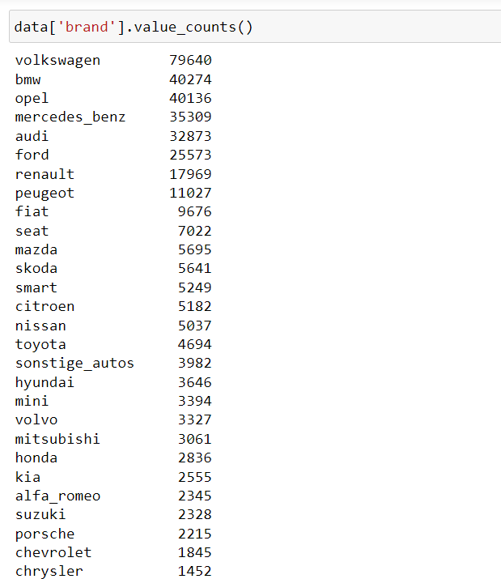

Now we show brand names on x-axis and count on y-axis.

The code shown below.

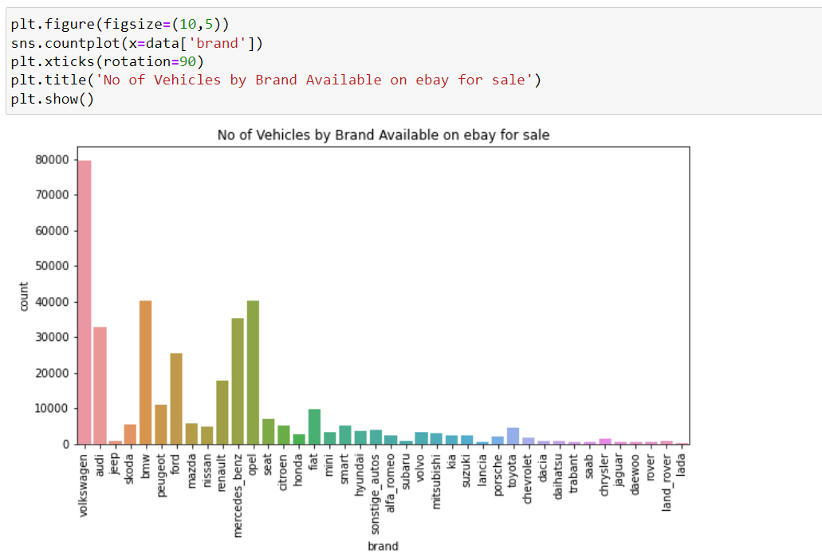

From the figure we can say that this is a plot of brand and its count

Where Volkswagen has the highest count of sales on ebay and lada brand is the least count of soled there are many brands which are soled very less.

2) What is the Average price for vehicles based on the type of vehicle as well as on the type of gearbox. Explain me with both numerical and visualization analysis.

To show the average price of vehicles based on the vehicle type and gear type we should use bar plot for this heat map.

To collect the average prices of both the vehicle type and gear box,

We can use pivort table by using it, we can take index as gear box, columns are vehicle type and values as price, pivort table default take the average.

Code for pivort table:

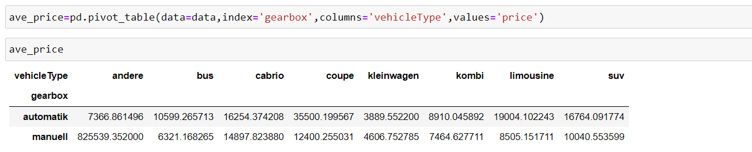

Here shows that the all average prices about the combination of vehicle type and gearbox.

So now we can use bar plot and heatmap also.

This is the code for bar plot ave_price.plot(kind="bar")

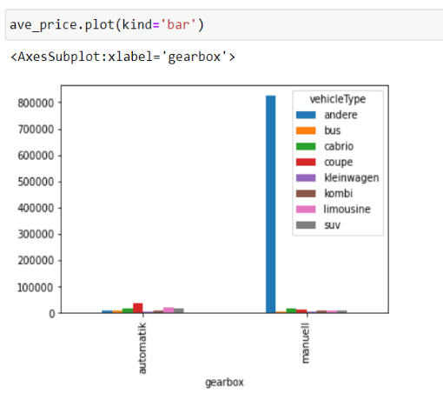

In this bar graph y-axis is average price and x- axis is gear box along with vehicle type.

By heat map also we can represent the average price of vehicles based on the vehicle type and gear type.

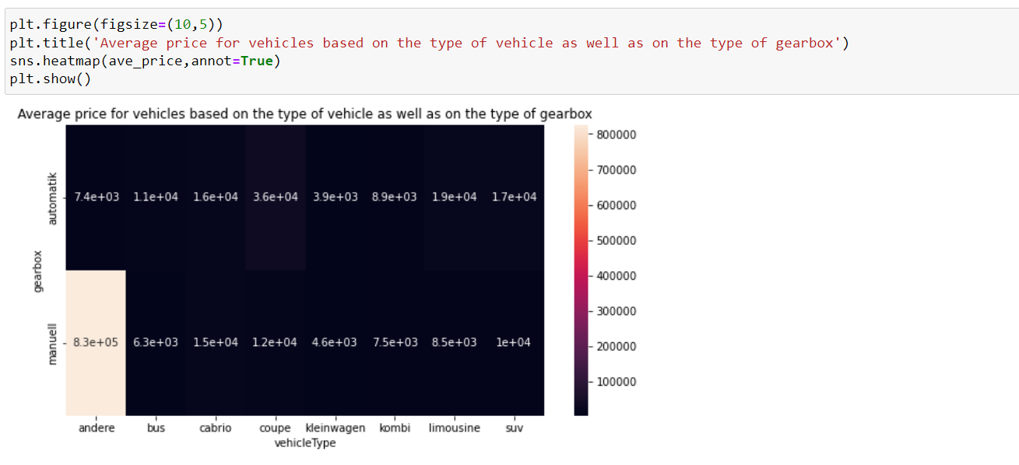

By color difference we can define the plot.

The vehicle name containing andere and gearbox as manuell has the highest average price among all the vehicle combinations of vehicle type and gear box.

1. What is the marginal probability of private seller.

To find the marginal probability for the “private” in the seller column

First we should know about the all types of sales in the seller column

For that we need to collect the seller column data as

data["seller"].value_counts()

this will gives you the information as

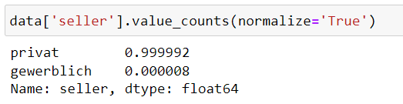

Here we have 371525 count of private sellers in the total sellers

And only 3 gewerbich sellers in the data

To get the marginal probability for the data we use the code as



In statstics we say that marginal probability that is normalize means marginal.

And the to know the marginal probability we can confirm that the all

Values true column gives the marginal probability for the private seller

* Here the marginal probability for private seller is 0.999992
* Here the marginal probability for not a private seller is 0.000008